**Ticket Creation Process for Saturn Account**

Version: 1.1

|  |  |
| --- | --- |
| Abstract: | This document will show us the process of Backup Monitoring for Saturn Account. |
| Protective Mark: | DXC |
| Document Number: | 1.0 |
| Document Author: | Chaitra Kulkarni |
| Document Reviewer: | Dipayan Dakshi |
| Document Approver: | Dipayan Dakshi |

Amendment Record

|  |  |  |  |
| --- | --- | --- | --- |
| **Version Control Log** | | | |
| **No** | **Date** | **By** | **Nature of change** |
| 1.0 | 2 February 2021 | Chaitra KUlkarni | Created document. |
| 1.1 | 16 August 2021 | Swapna Kumari | Updated in new DXC format |
|  |  |  |  |
|  |  |  |  |
|  |  |  |  |

* Use the below URL to access service now: <https://csc.service-now.com/navpage.do>
* After logging into the console home page will appear. To create a New Incident, follow: Incident à Create New.

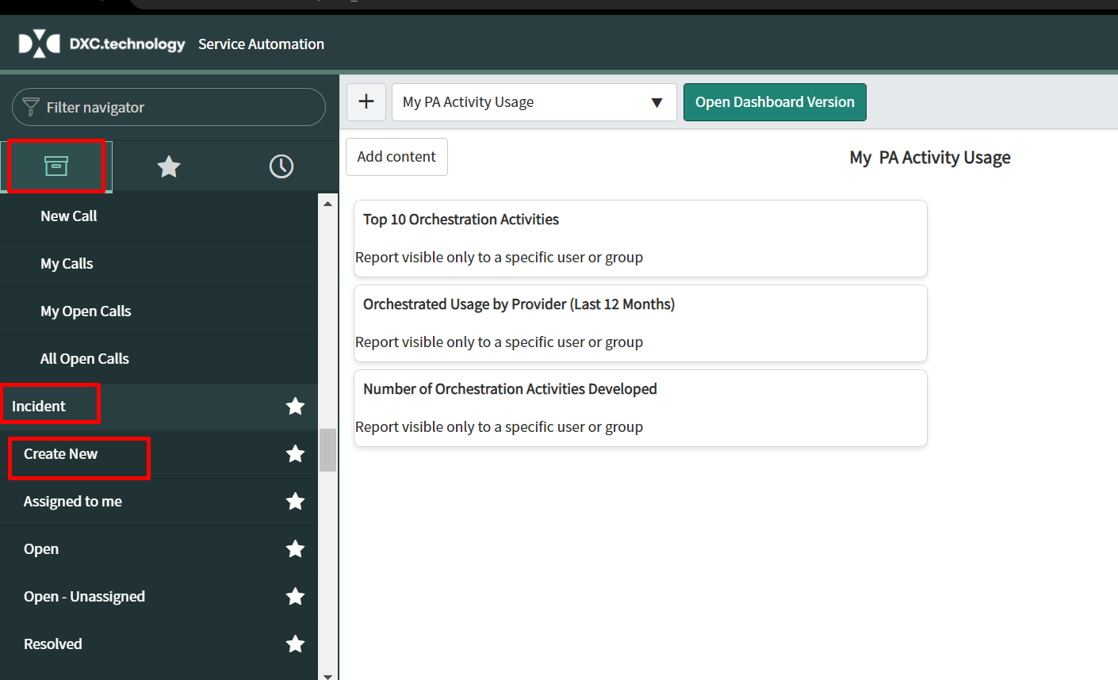

* Fill the below mentioned fields:
* Company : London Market
* Caller : Test Lonm
* Email and business phone fields will be autofilled.

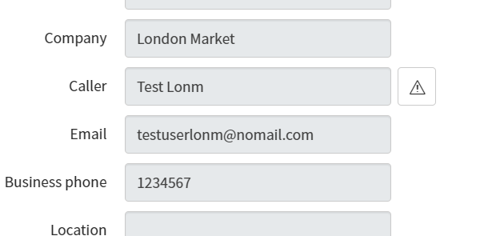

* Category : Storage
* Subcateogry : Failure

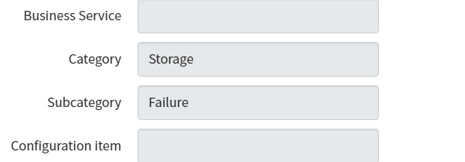

* Description : Provide the error log of the backup failure.
* Short description : Put a brief discription ( ex :Incompleted, failed, failed with and exception) along with the client name with a prefix “Saturn backup”.
* Please refer the below attached document for deciding the priority of the ticket.



* Assignment Group : Backup Support – LONM
* Assigned to : Assign to the primary on call person.

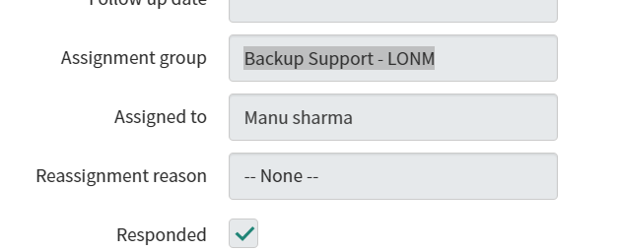

* Save the ticket.
* Note :Do not forget to check the respond box.